# Brick Order Test Document

Contents

Brick Order Test Document 1

Introduction 2

Stage 1 3

Test Name: Submit new orders for Bricks 3

Test Name Create Order missing details no customer name 4

Step 3: Create Order missing quantity 5

Stage 2: GetOrders 6

Step 1: Get Valid Order 6

Step 2: Order does not exist 7

Step 3: Get All orders 7

Stage 3: Update Orders 9

Test Name: Update a valid record 9

Test Name: Missing reference Number 11

Test Name: Missing Quantity 12

Stage 3 Order Fulfilled 13

Test Name: Full fill an order 13

Test Name: Invalid Reference 14

Test Name: No reference 15

Stage 4 16

Test Name: Update Fullfilled Order 16

# Introduction

This documentation details the test cases and results for the Brick Order solution

## Stage 1

### Test Name: Submit new orders for Bricks

#### Steps

1. Create valid new Order

METHOD: POST

URL: <http://localhost:8080/BrickOrders/rest/RestService/Order>

Encoded: x-www-form-urlencoded

Form Data:

Id: 1

Quantity: 20

Customercode: CAM

#### Expected Result

Order Created and unique reference returned

#### Test Results

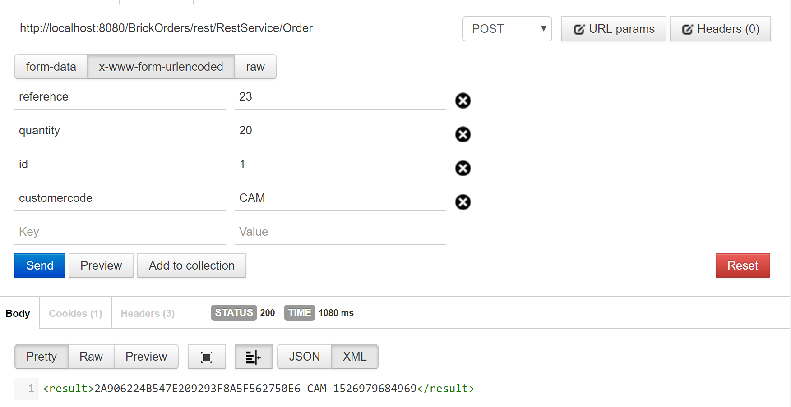

#### Test Status

Pass<result>2A906224B547E209293F8A5F562750E6-CAM-1526979684969</result>

### Test Name Create Order missing details no customer name

#### Steps

1. Create order excluding quantity

METHOD: POST

URL: <http://localhost:8080/BrickOrders/rest/RestService/Order>

Encoded: x-www-form-urlencoded

Form Data:

Quantity: 20

#### Expected Result

Order rejected

#### Test Results

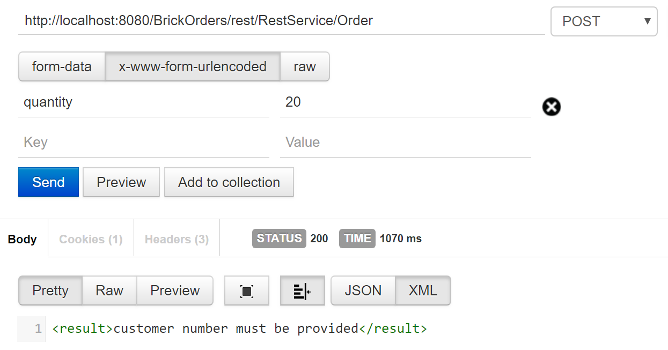

### Step 3: Create Order missing quantity

#### Steps

1. Create query using following values excluding the quantity

METHOD: POST

URL: <http://localhost:8080/BrickOrders/rest/RestService/Order>

Encoded: x-www-form-urlencoded

Form Data:

Customercode: CAM

#### Expected Result

Order Not Created

#### Test Results

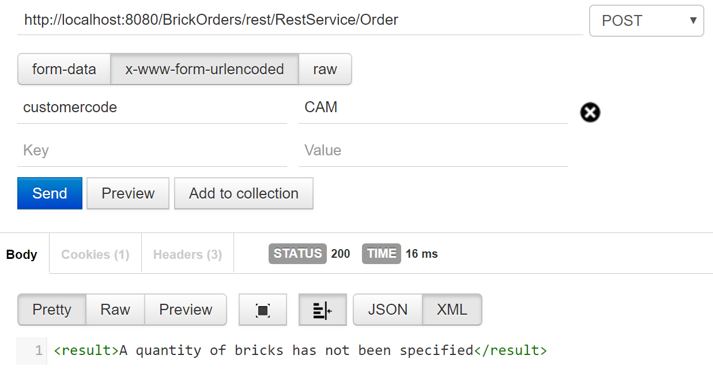

## Stage 2: GetOrders

### Step 1: Get Valid Order

Generate a query using the values below to get an existing record.

METHOD: GET

URL: <http://localhost:8080/BrickOrders/rest/RestService/GetOrder>/2A906224B547E209293F8A5F562750E6-CAM-1526979684969

#### Expected Result

Order Details returned

#### Test Results

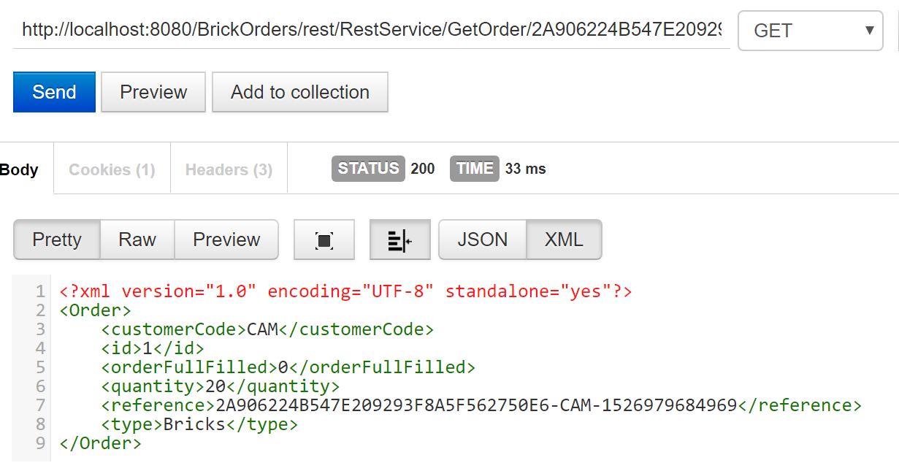

#### Test Status

Passed record exists

### Step 2: Order does not exist

#### Steps

1. Create a query using the information below

METHOD: GET

*URL: http://localhost:8080/BrickOrders/rest/RestService/GetOrder/*2A906224B54

#### Expected Results

Record not found

#### Test Result

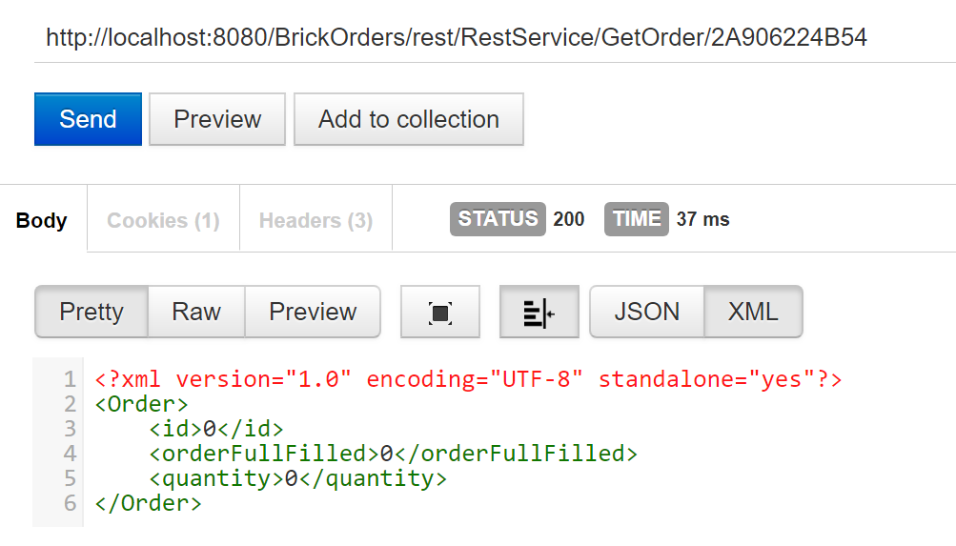

http://localhost:8080/BrickOrders/rest/RestService/GetOrder/2A906224B54

### Step 3: Get All orders

#### Steps

Execute the URL to obtain all records

URL: <http://localhost:8080/BrickOrders/rest/RestService/GetOrders>

#### Expected Result

All records returned

#### Test Result

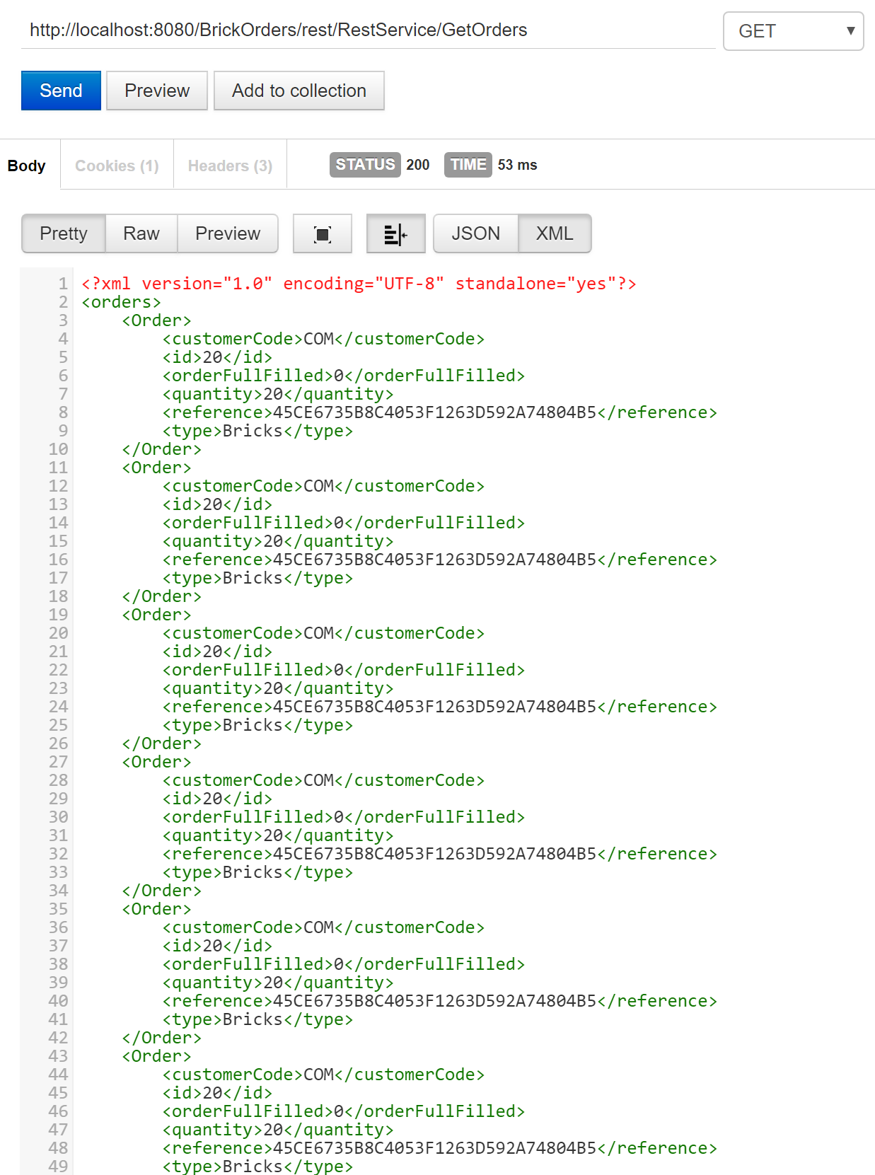

#### Test Status

All records returned PASSED

## Stage 3: Update Orders

### Test Name: Update a valid record

#### Steps

1. Get the details of an existing record

<http://localhost:8080/BrickOrders/rest/RestService/GetOrder/2A906224B547E209293F8A5F562750E6-CAM-1526979684969>

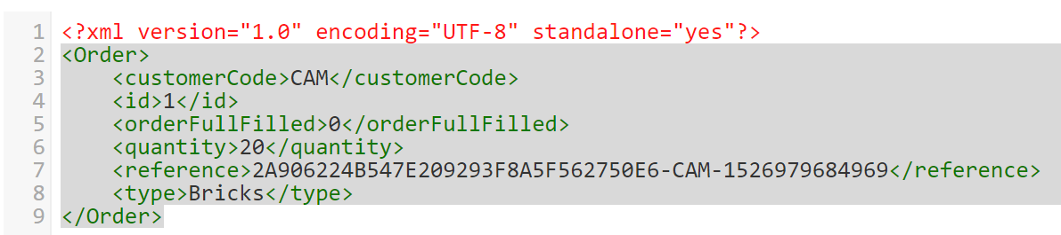

1. Execute a query using the information below

METHOD: PUT

URL: <http://localhost:8080/BrickOrders/rest/RestService/UpdateOrder/>

Encoded: x-www-form-urlencoded

Reference: 2A906224B547E209293F8A5F562750E6-CAM-1526979684969

Quantity: 200

3.Execute a get Order request to check the Order has been updated

METHOD: GET

URL: <http://localhost:8080/BrickOrders/rest/RestService/GetOrder>/2A906224B547E209293F8A5F562750E6-CAM-1526979684969

#### Expected Result

Order quantity updated to 200

#### Test Results

Update Request

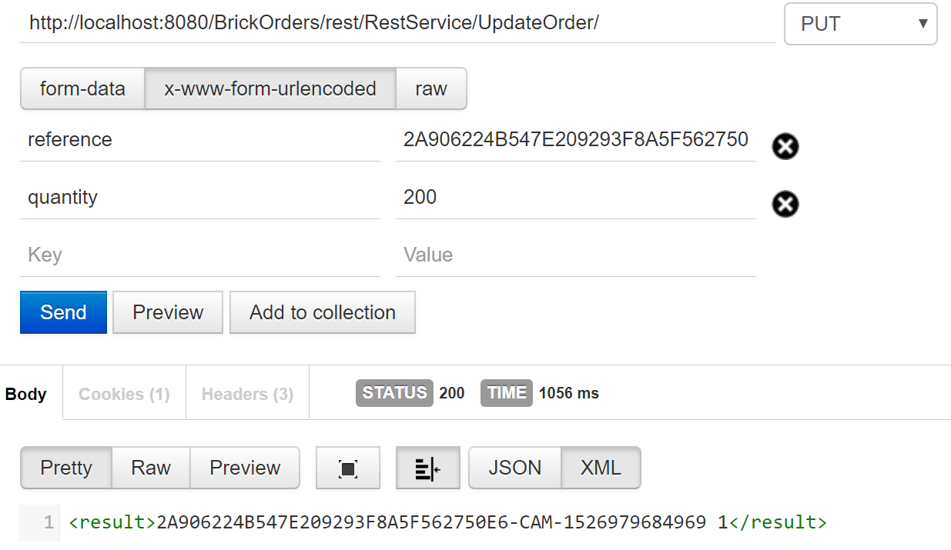

Get Order Query

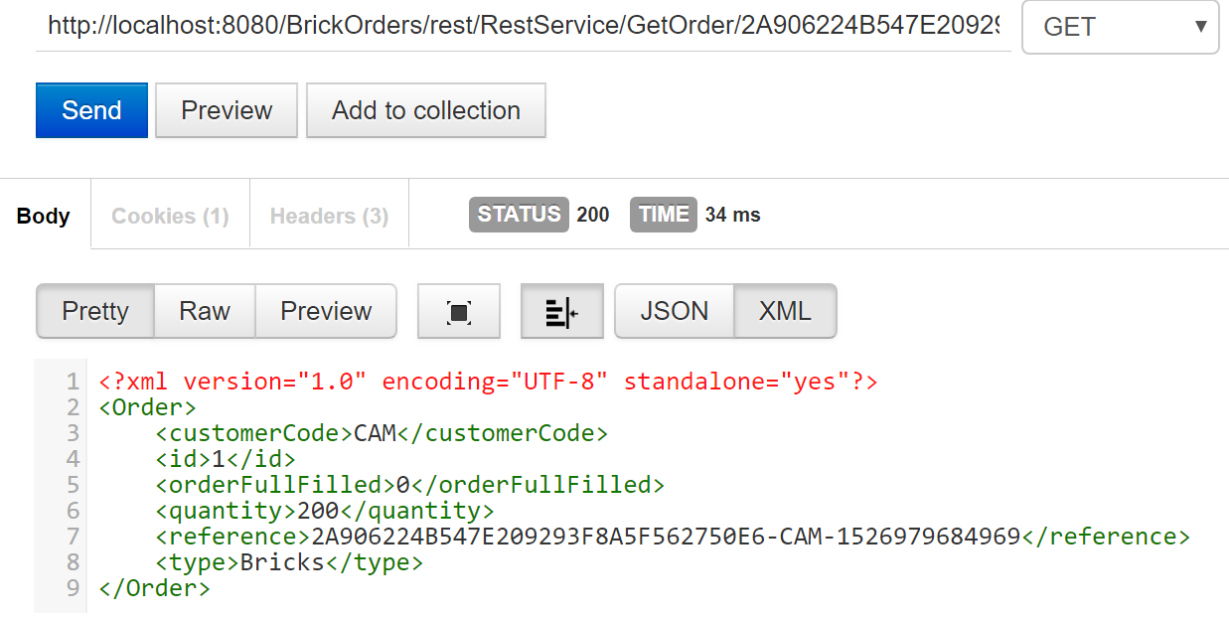

#### Test Status

Record Updated: Pass

### Test Name: Missing reference Number

#### Steps

1. Create a query using omitting the reference number using the information below

METHOD: PUT

URL: <http://localhost:8080/BrickOrders/rest/RestService/UpdateOrder/>

Form:

Encoded: x-www-form-urlencoded

Reference:

Quantity: 200

#### Expected Result

Order rejected

#### Test Results

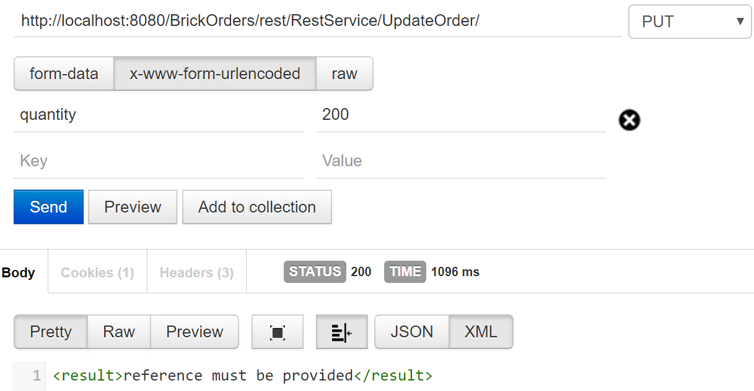

#### Test Status:

Test passed

### Test Name: Missing Quantity

#### Steps

1. Create a query omitting the order quantity using the information below

METHOD: PUT

URL: <http://localhost:8080/BrickOrders/rest/RestService/UpdateOrder/>

Form:

Encoded: x-www-form-urlencoded

Reference: none

#### Expected Result

Query rejected

#### Test Results

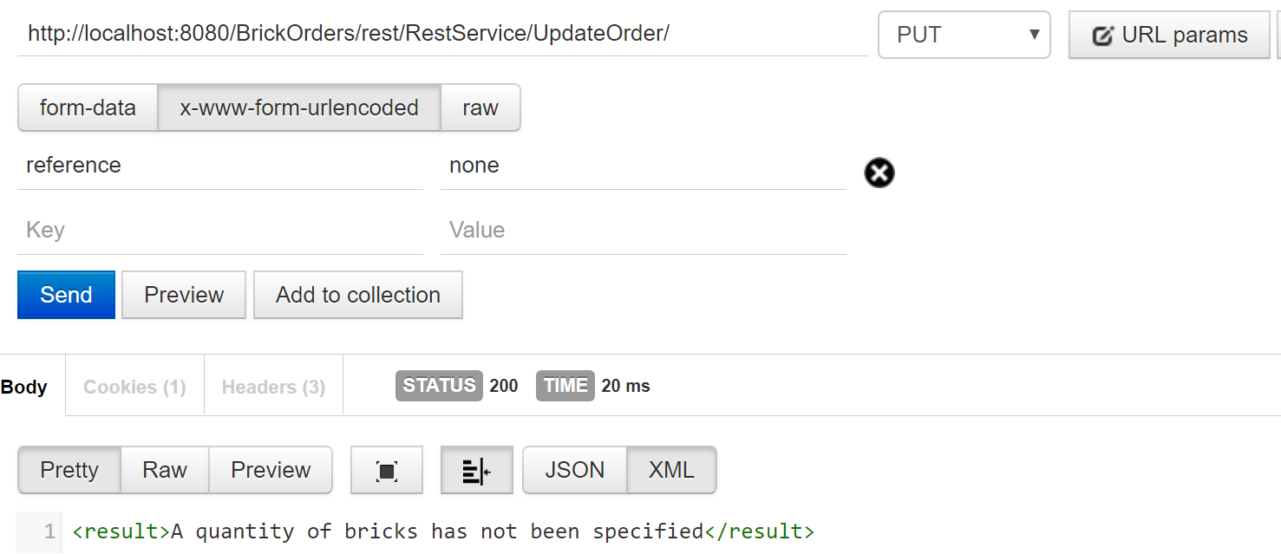

#### Test Status

Test passed

## Stage 3 Order Fulfilled

### Test Name: Full fill an order

#### Steps

1. Create a URL to an existing record and set if to full filled using the information below.

METHOD: PUT

URL: <http://localhost:8080/BrickOrders/rest/RestService/UpdateOrder/>

Form:

Encoded: x-www-form-urlencoded

Reference: [2A906224B547E209293F8A5F562750E6-CAM-1526979684969](http://localhost:8080/BrickOrders/rest/RestService/GetOrder/2A906224B547E209293F8A5F562750E6-CAM-1526979684969)

1. Create a URL to get the full filled order and check it is updated.

METHOD: GET

URL: <http://localhost:8080/BrickOrders/rest/RestService/GetOrder/>[2A906224B547E209293F8A5F562750E6-CAM-1526979684969](http://localhost:8080/BrickOrders/rest/RestService/GetOrder/2A906224B547E209293F8A5F562750E6-CAM-1526979684969)

#### Expected Result

Order is full filled

#### Test Results

Order Full filled

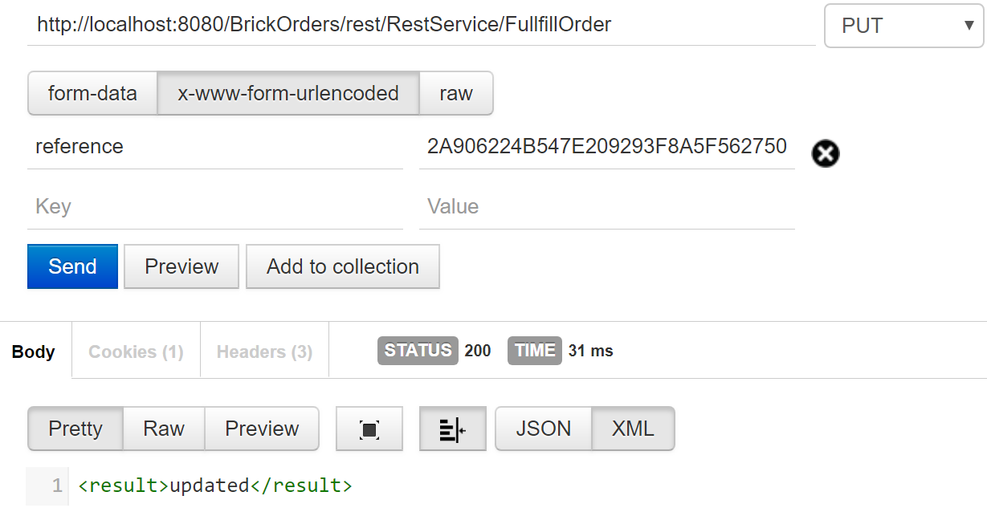

Get Order request to verify update

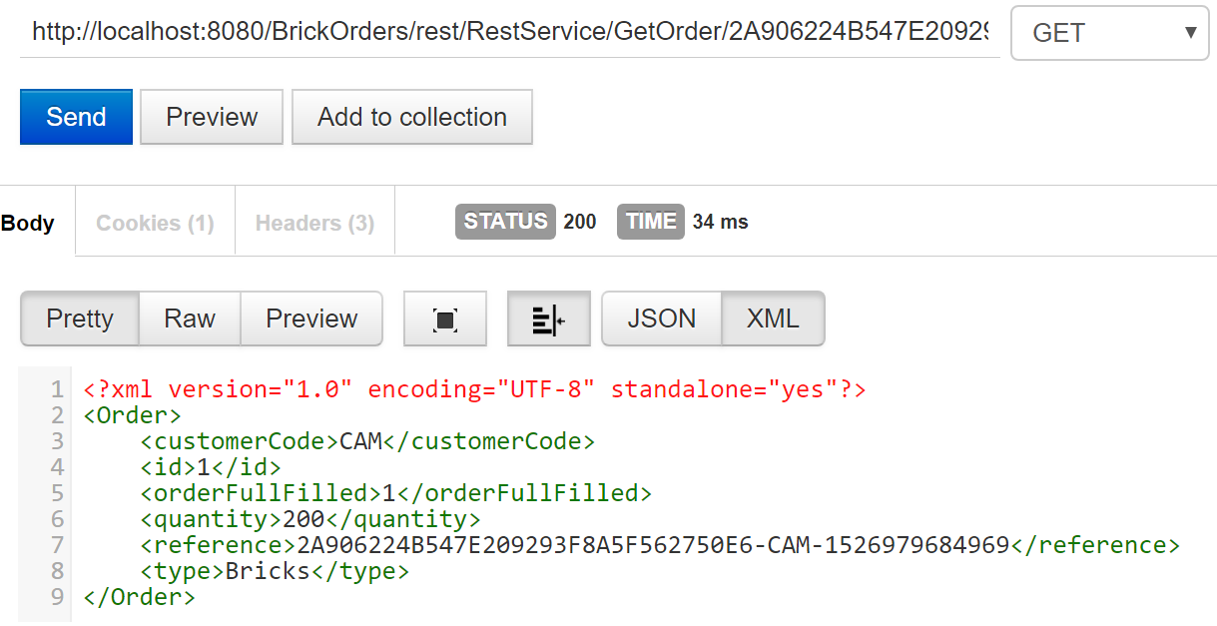

#### Test Status

Test passed

### Test Name: Invalid Reference

#### Steps

1. Create a URL to a non existing record and set if to full filled using the information below.

METHOD: PUT

URL: <http://localhost:8080/BrickOrders/rest/RestService/UpdateOrder/>

Form:

Encoded: x-www-form-urlencoded

Reference: [2A906224B54](http://localhost:8080/BrickOrders/rest/RestService/GetOrder/2A906224B547E209293F8A5F562750E6-CAM-1526979684969)

#### Expected Result

Order is rejected

#### Test Results

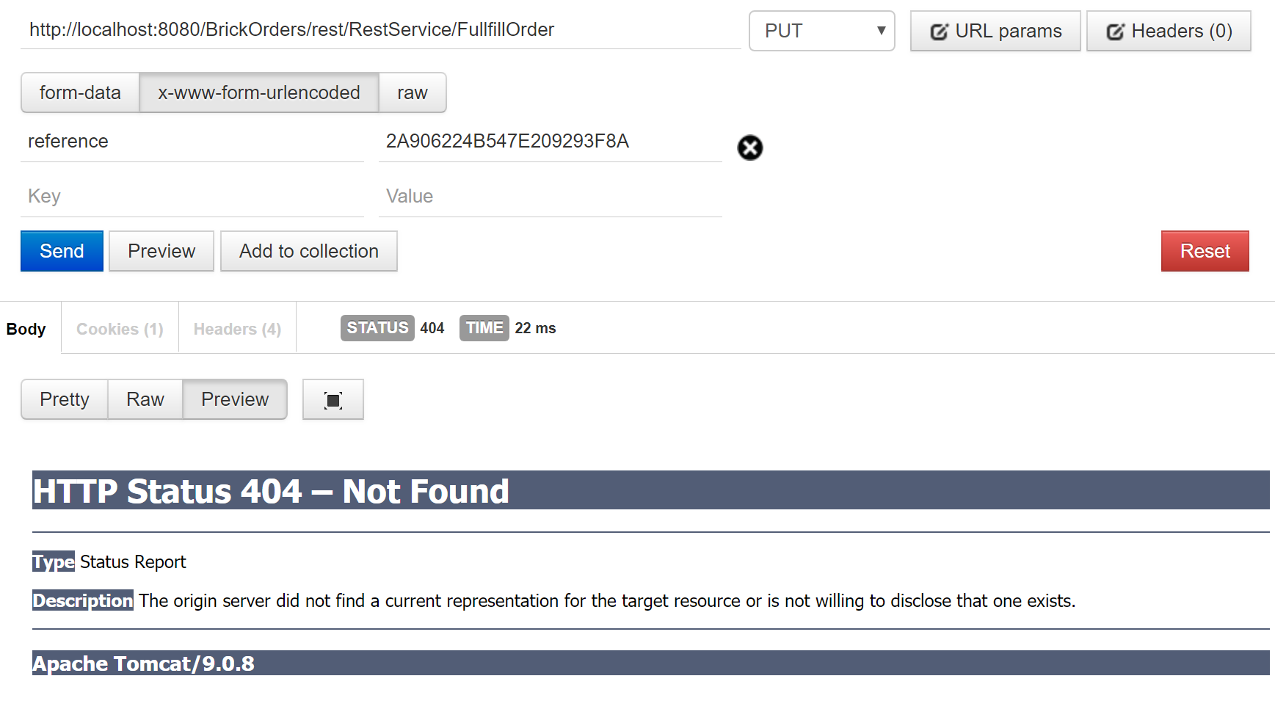

#### Test Results

Test passed

### Test Name: No reference

#### Steps

1. Create a URL to a non existing record and set if to full filled using the information below.

METHOD: PUT

URL: <http://localhost:8080/BrickOrders/rest/RestService/UpdateOrder/>

Form:

Encoded: x-www-form-urlencoded

#### Expected Result

Order is rejected

#### Test Result

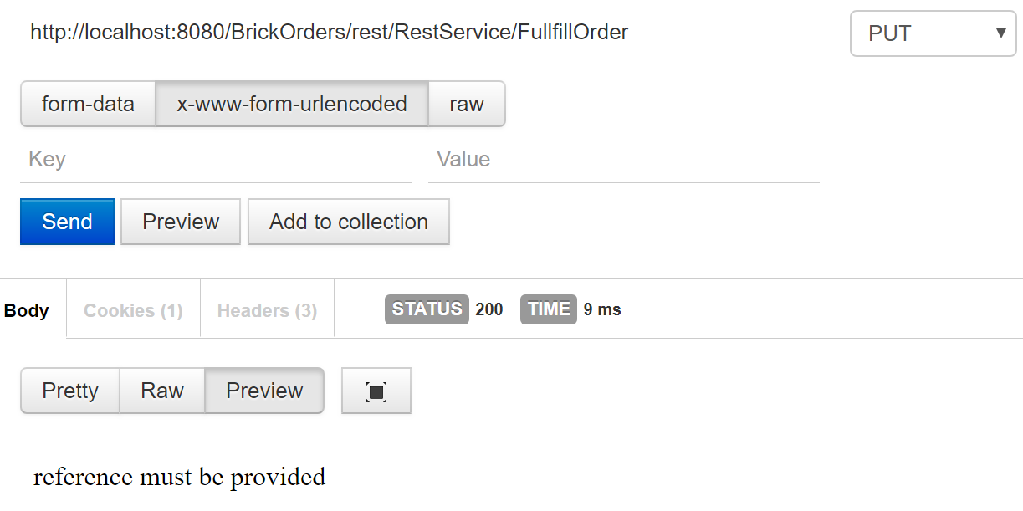

#### Test Status

Test Passed

## Stage 4

### Test Name: Update Fullfilled Order

Steps

1. Execute a get Order request to check that the record is already full filled

METHOD: GET

URL: <http://localhost:8080/BrickOrders/rest/RestService/GetOrder>/2A906224B547E209293F8A5F562750E6-CAM-1526979684969

1. Execute query using information below to attempt to updated a record that has been fulfilled.

METHOD: PUT

URL: <http://localhost:8080/BrickOrders/rest/RestService/UpdateOrder/>

Form:

Encoded: x-www-form-urlencoded

reference: 2A906224B547E209293F8A5F562750E6-CAM-1526979684969

quantity: 600

1. Execute a get Order request to check the Order has been updated

METHOD: GET

URL: <http://localhost:8080/BrickOrders/rest/RestService/GetOrder>/2A906224B547E209293F8A5F562750E6-CAM-1526979684969

#### Expected Result

Order is rejected, and a 404 page is displayed

#### Test Results

Before



Update Query

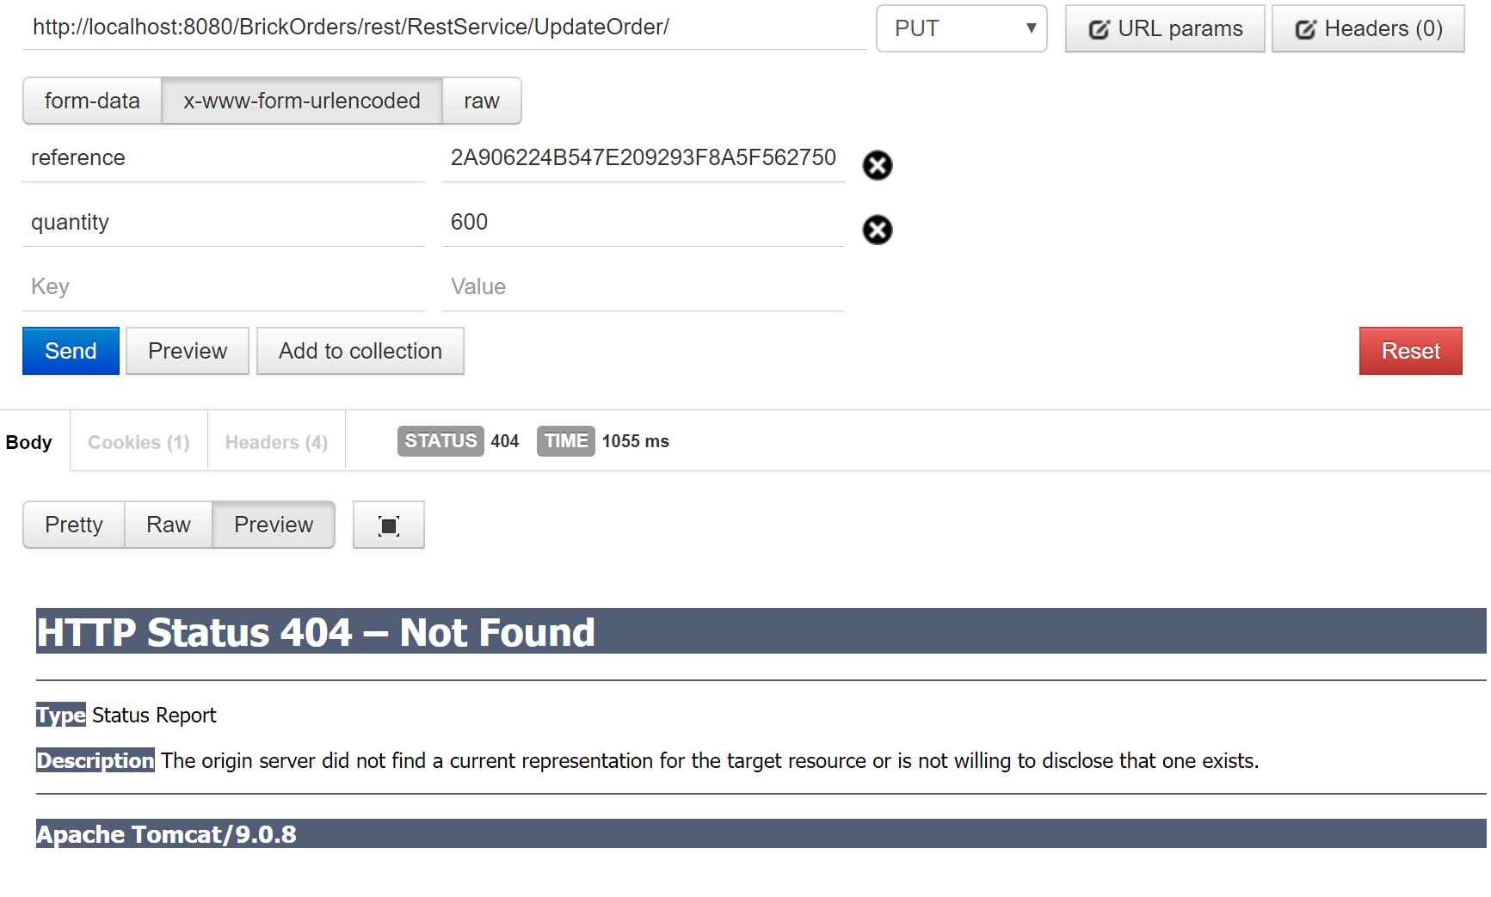

Quantity not updated

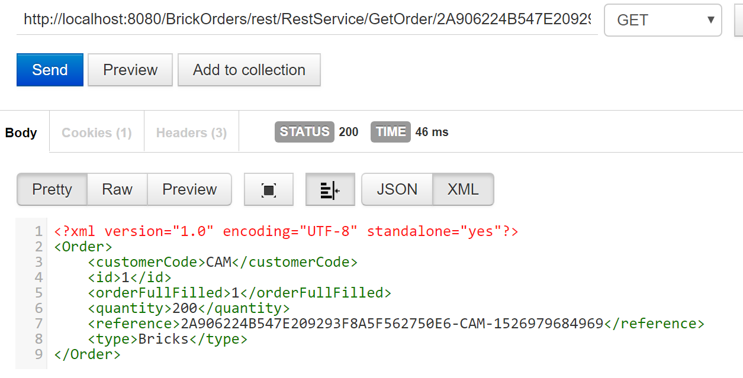

#### Test Status

Test passed